**A CRM application for schools /colleges**

**1 Introduction:**

1.1Overview:

A CRM is a system that helps schools manage the entire life cycle of a potential customer.

1.2 Purpose:

A school CRM software is a specialized tool designed to manage and track student interactions ,data and automate tasks related to student recruitment, enrollment and retention.

**2.Promblem definition & design Thinking:**

**2.1.Empathy map:**

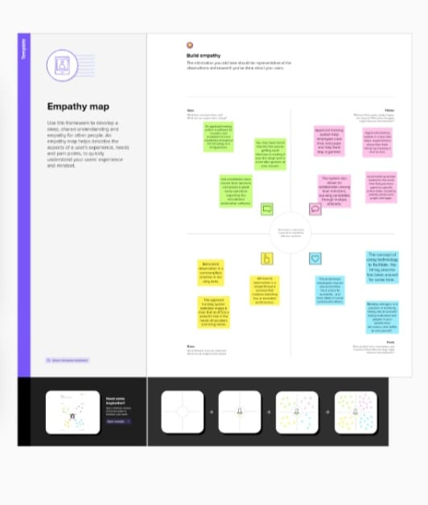

2.2 Ideation & Brainstorming map:

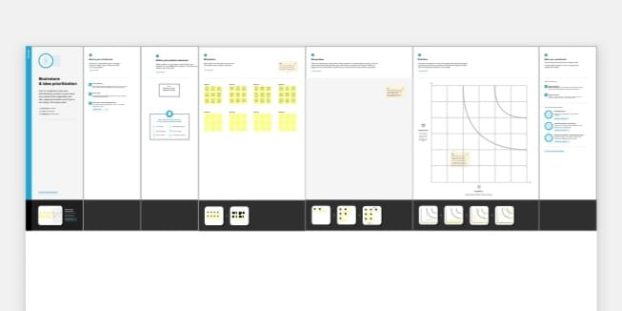

**3 RESULT:**

3.1.Data model:

|  |  |
| --- | --- |
| **Object name** | **Fields in the objects** |
| **School** | |  |  | | --- | --- | | **FIELD LABEl** | **DATA TYPE** | | **Address** | **Text area** | | **District** | **Text** area | | **State** | **Text area** | | **School website** | **Text area** | | **Phone number** | **Phone** | | **Number of Students** | **Roll-up summary** | | **Highest mark** | **Roll up summary** | |
| **Student** | |  |  | | --- | --- | | **Phone number** | **Phone** | | **Results** | **Picklist** | | **school** | **Master Detail relationship** | | **Class** | **Number** | | **Marks** | **Number** | |
| **Parent** | |  |  | | --- | --- | | **Parent number** | **Phone** | | **Parent address** | **Text area** | |

3.2.Activity & screenshot**:**

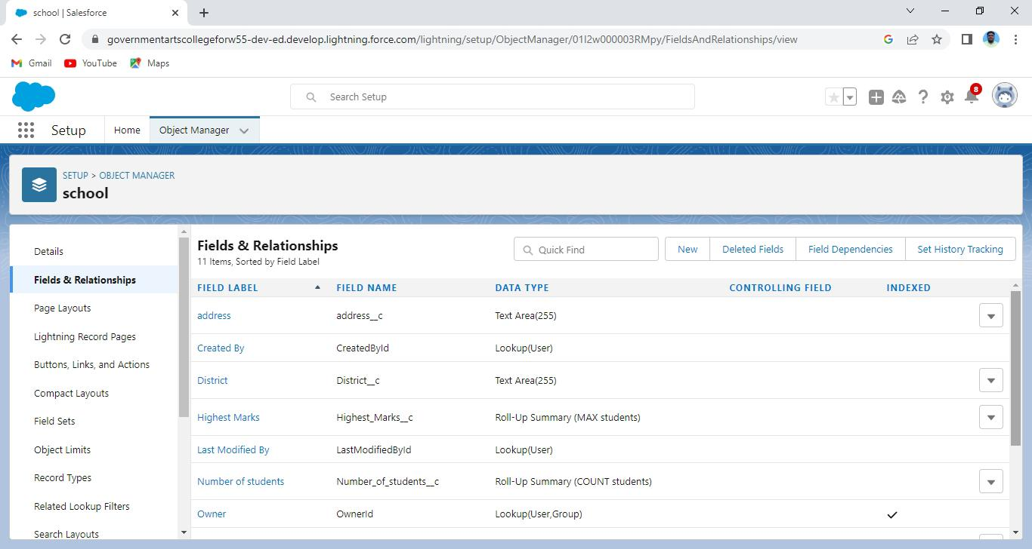

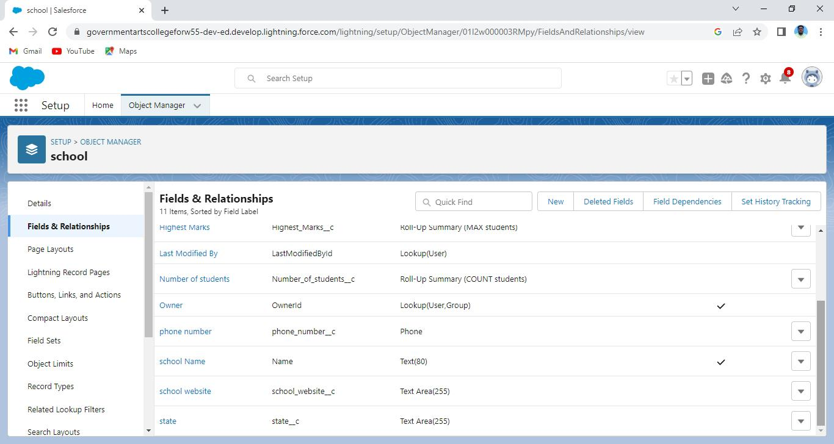

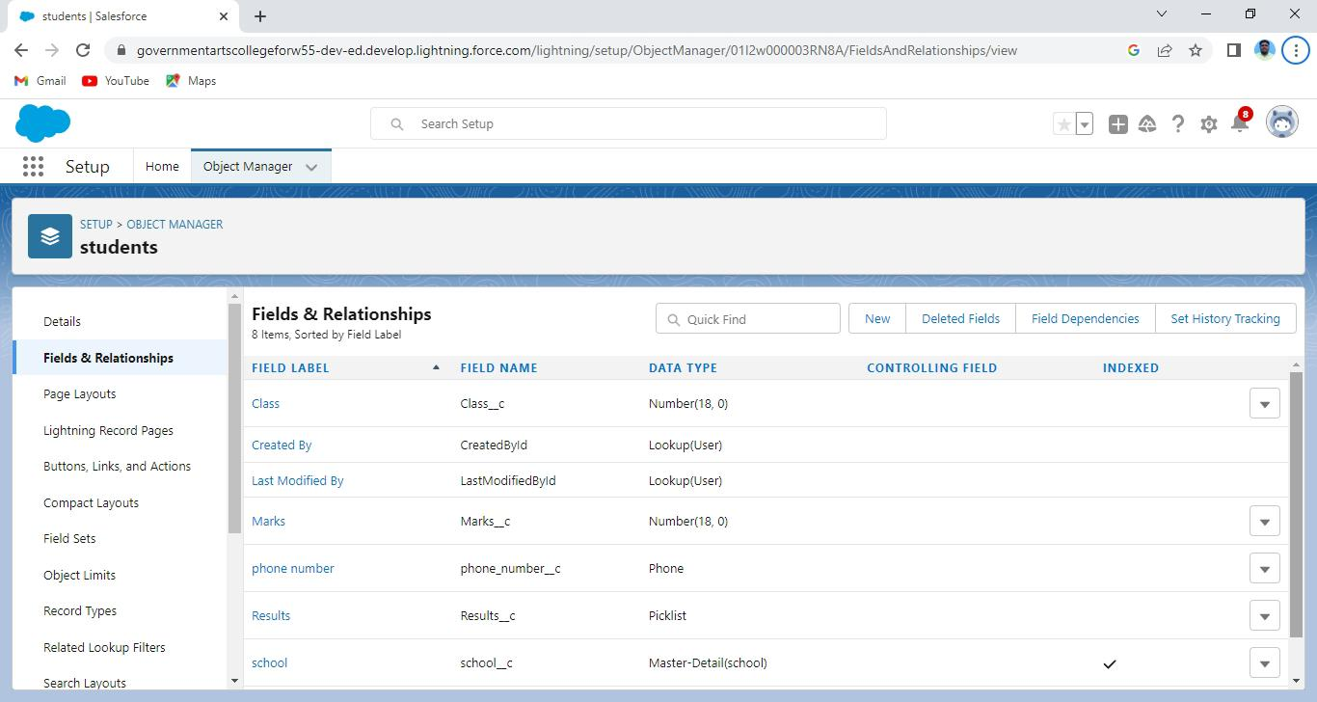

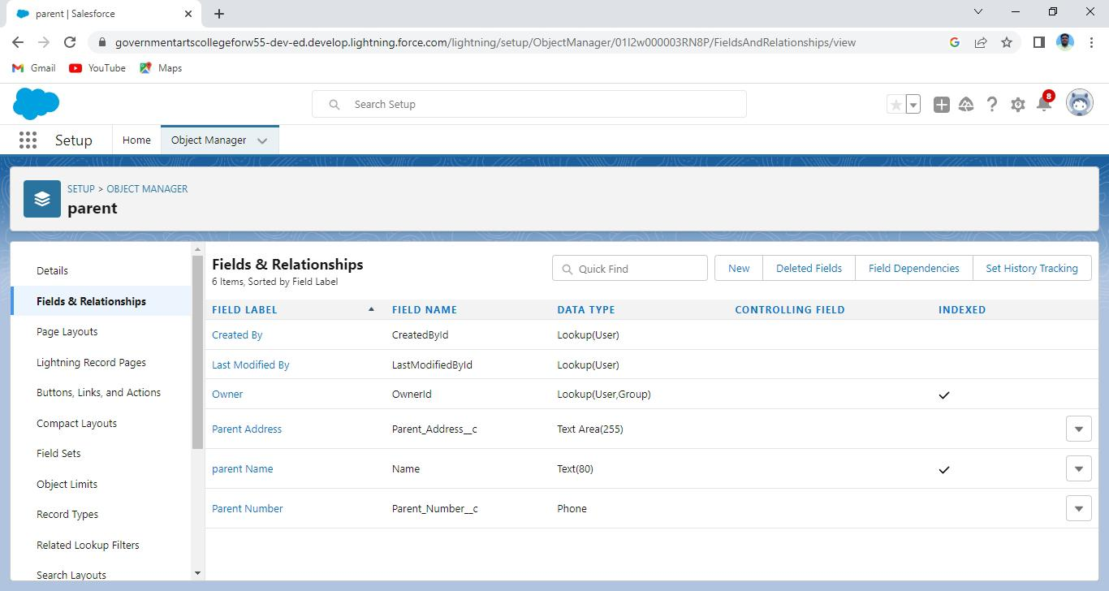

**4.Trailhead profile public URL:**

Team lead-https://trailblazer.me/id/vengk2

Team member 1-https://trailblazer.me/id/jkohli16

Team member 2-https://trailblazer.me/id/sselva234

Team member 3-https://trailblazer.me/id/rajam94

Team member 4-https://trailblazer.me/id/ayogapriya

**5.ADVANTAGES:**

* Reduction in the cost of expenses
* Improving the quality of service/product
* Improving the organisation management process
* History of work with each student
* Easy implementation.

**DISADVANTAGES:**

* Loss of collected information or records
* Not suitable for every business
* It eliminates the human element
* Having lots of security concerns

**6.APPLICATIONS:**

* Lead centralization
* Lead management
* Sales management &automation
* Field force automation
* User management
* Marketing communications and automation

**7.CONCLUSIONS:**

Customer relationship management enables a company to align it’s strategy with the needs of the customer in order to best meet those needs and thus ensure long term customer loyalty.

**8.FUTURE COALS:**

A CRM let’s you track data and analytics from your recruitment and marketing efforts so that it strikes a chord with prospective students.